Web Development

WEDE5020

Tatum Bruiners

ST10513693

Group 1

Table of Contents
Cover Page………………………………………………………………………………………………………………………………1
Table of Contents……………………………………………………………………………………………………………………..2
Organisation Overview 3
Name 3
Brief History 3
Mission and Vision 3
Target Audience 3
Website Goals and Objectives 4
Goals 4
Objectives 4
Key Performance Indicators (KPIs) 4
Current Website Analysis 5
Strengths 5
Weaknesses 5
Areas of Improvement 5
Proposed Website Features and Functionality 6
Features 6
Functionality 6
Design and User Experience 7
Colour Scheme 7
Typography 7
Layout and Design 7
User Experience Considerations 7
Low-fidelity Wireframes 7
Technical Requirements 8
Domain Name 8
Hosting 8
Programming Language and Framework 8
Timeline and Milestones 9
Budget 10
Development 10
Domain 10
Hosting 10
Maintenance 10
References 11

Organisation Overview

Name
The organisation chosen for this project is Ackermans (Pepkor, 2024).

Brief History
Ackermans was founded in 1916 in Wynberg, Cape Town and started as a small retail store (Ackermans, 2026). Later it expanded and is now currently one of the largest value retail chains in Southern Africa (Enterprise Africa, 2026). It operates as part of the Pepkor Group and has hundreds of stores across the region, offering affordable clothing and household goods to everyday consumers (Pepkor, 2024).

Mission and Vision
Ackermans focuses on providing affordable, good-quality clothing and essential products to families. Its mission is to make value-based shopping accessible to all communities while maintaining customer satisfaction and trust (Enterprise Africa, 2026).

Target Audience
Ackermans targets:
- Families looking for affordable clothing
- Low to middle-income customers
- Students and young adults on a budget
- Parents shopping for children
- Everyday shoppers looking for value products (Ackermans, 2026)

Website Goals and Objectives

Goals
The main goal of the website is to make it easy for customers to browse and shop affordable products online. The website also aims to improve accessibility for mobile users and increase engagement with the brand (Ackermans, 2026).

Objectives
To achieve these goals, the website will focus on:
- Improve speed and ease of product browsing
- Increase mobile shopping usage
- Improve online enquiries for products
- Encourage customers to visit physical stores
- Reduce time needed to find products (ToolsGroup, 2025)

Key Performance Indicators (KPIs)
The success of the website will be measured using:
- Monthly website visits
- Product page clicks and engagement
- Enquiry form submissions
- Mobile vs desktop usage rate
- Average browsing time per session (Bunnypants, 2026)

Current Website Analysis

Strengths
- Strong brand recognition in South Africa
- Wide range of affordable products
- Simple and familiar navigation system
- Trusted retail presence in local communities (Enterprise Africa, 2026)

Weaknesses
- Website design is not fully optimised for mobile users
- Product categories can feel crowded
- Limited interactive features compared to modern e-commerce platforms
- Some pages take longer to load during peak traffic times (ToolsGroup, 2025)

Areas of Improvement
- Improve mobile responsiveness and layout structure
- Simplify navigation for faster product access
- Improve product filtering and search functions
- Reduce visual clutter on key pages (Bunnypants, 2026)

Proposed Website Features and Functionality

Features
The website will include the following main pages: a homepage, about us, product section, enquiry form and contact page (Jelly Design Studio, 2025).

Functionality
- Homepage: This will be the first page users see. It will include a hero image, brief introduction, featured products and clear buttons to start shopping.
- About Us: This page will explain Ackermans’ background and its role in the South African market. It will also include the mission, vision and team members.
- Product Menu: This section will organise products into different clothing categories such as women, men, children and babies (Nicola, 2025).
- Enquiry Form: Users will be able to ask questions or request product information.
- Contact Page: This will include customer support details, maps of their branches and important contact information.

Design and User Experience

Colour Scheme
The website will use red, white and green. Red is already associated with Ackermans branding and will be used to highlight promotions and important actions. White will be used for background to keep the design clean and readable (Ackermans, 2026).

Typography
A simple font such as Arial will be used because it is easy to read across different devices. Headings will be bold to create clear structure, while body text will remain simple for readability (Etsy, 2026).

Layout and Design
The layout will be structured into clear sections such as header, navigation bar, content area and footer. This helps users find information quickly and improves overall usability. The design will avoid unnecessary clutter to improve focus on products (Bunnypants, 2026).

User Experience Considerations
The website will be designed to be mobile-friendly, fast-loading and easy to navigate. This ensures users can complete actions such as browsing or searching products without confusion (Enterprise Africa, 2026).

Low-fidelity Wireframes
Below is an image to visualise the website’s layout and information hierarchy using low-fidelity wireframes:
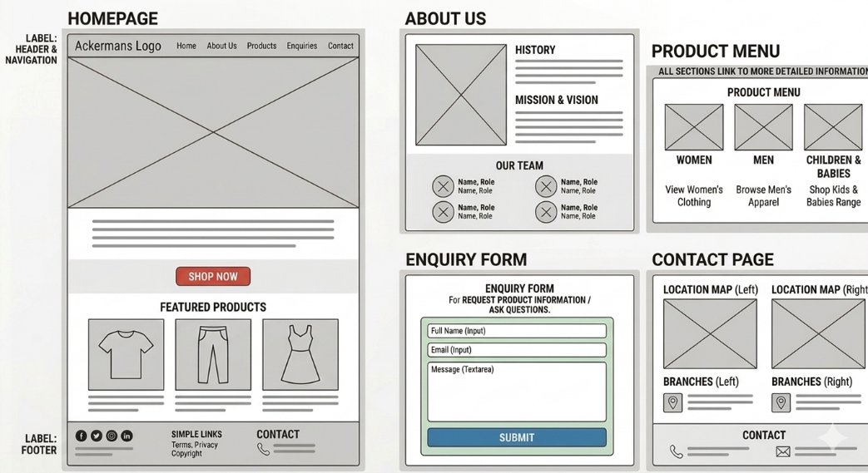

Technical Requirements

Domain Name
A suitable domain could be “ackermans-online.co.za”. This makes the website easy to identify and locally relevant (ZADNA, 2025).

Hosting
Hosting is required to store the website files and make the site accessible on the internet (HOSTAFRICA, 2024). The website will be built using Visual Studio Code and managed through GitHub. GitHub Pages will then be used to publish the website online.

Programming Language and Framework
The website will use HTML, CSS and JavaScript. HTML will structure the pages, CSS will handle the design and layout and JavaScript will add interactivity such as forms and user actions (Mozilla, 2026).

Timeline and Milestones
Activity | Feb 2026 | Mar 2026 | Apr 2026 | May 2026 | June 2026
Planning Project
Research and Content Gathering
Create HTML Structure - Part 1
Organise your Files
Apply CSS Styling - Part 2
Create a Responsive Design
Optimise for User Experience
Implement JavaScript - Part 3
Optimise for SEO
Create Functional Forms
Integrate External Services

Budget

Development
The estimated cost for developing a simple version of the website is between R9000 and R15000 (Bunnypants, 2026).

Domain
The domain will cost around R150 to R300 per year (ZADNA, 2025).

Hosting
Monthly hosting costs are estimated between R300 and R500 (Allanux Web, 2026).

Maintenance
Ongoing maintenance and updates may cost between R500 and R2000 per month (Woww, 2025).

References
- Ackermans. (2026) About us. Available at: https://www.ackermans.co.za/pages/about-us (Accessed: 19 April 2026).
- Allanux Web. (2026) Website maintenance costs in South Africa: 2026 pricing guide. Available at: https://www.allanuxweb.com/blog/website-maintenance-costs (Accessed: 19 April 2026).
- Bunnypants. (2026) What is the cost of creating a website in South Africa (2026)? Available at: https://www.bunnypants.co.za/what-is-the-cost-of-creating-a-website-in-south-africa-2026/ (Accessed: 19 April 2026).
- Enterprise Africa. (2026) Ackermans: Vision of value at Ackermans' heart. Available at: https://enterprise-africa.net/ackermans-vision-of-value-at-ackermans-heart-2/ (Accessed: 19 April 2026).
- Etsy. (2026) Branding colors and fonts guide. Available at: https://www.etsy.com/market/branding_colors_fonts (Accessed: 19 April 2026).
- HOSTAFRICA. (2024) Web hosting vs domain name: What you need to know. Available at: https://hostafrica.co.za/blog/domains/domain-basics/domain-vs-hosting/ (Accessed: 19 April 2026).
- Jelly Design Studio. (2025) 5 must-have service-based website pages to build trust and book clients. Available at: https://jellydesignstudio.com/service-based-website-page/ (Accessed: 19 April 2026).
- Mozilla. (2026) MDN Web Docs. Available at: https://developer.mozilla.org/en-US/ (Accessed: 19 April 2026).
- Nicola. (2025) 5 essential pages every small business website needs. Available at: https://www.webador.com/blog/5-essential-pages-every-small-business-website-needs/ (Accessed: 19 April 2026).
- Pepkor. (2024) Pepkor integrated report 2024. Available at: https://www.pepkor.co.za/investor-relations/ (Accessed: 19 April 2026).
- ToolsGroup. (2025) Ackermans: Button-up top-town stock mix visibility. Available at: https://www.toolsgroup.com/customer-stories/ackermans-button-up-top-town-stock-mix-visibility/ (Accessed: 19 April 2026).
- Woww. (2025) What should I pay a web designer in South Africa. Available at: https://woww.co.za/what-should-i-pay-a-web-designer-in-south-africa/ (Accessed: 19 April 2026).
- ZADNA. (2025) Registry fee adjustment and multi-year registration policy for .za domains. Available at: https://www.zadna.org.za/registry-fee-adjustment-and-multi-year-registration-policy-for-za-domains (Accessed: 19 April 2026).

